**Диагностическая работа по математике 11 класс**

Вариант

*К каждому заданию 1 – 7 даны 4 варианта ответа, из которых только один правильный. Номера выбранных ответов на задания 1 – 7 обведите кружком.*

**1.**  Укажите график функции, заданной формулой у = 0,5х.

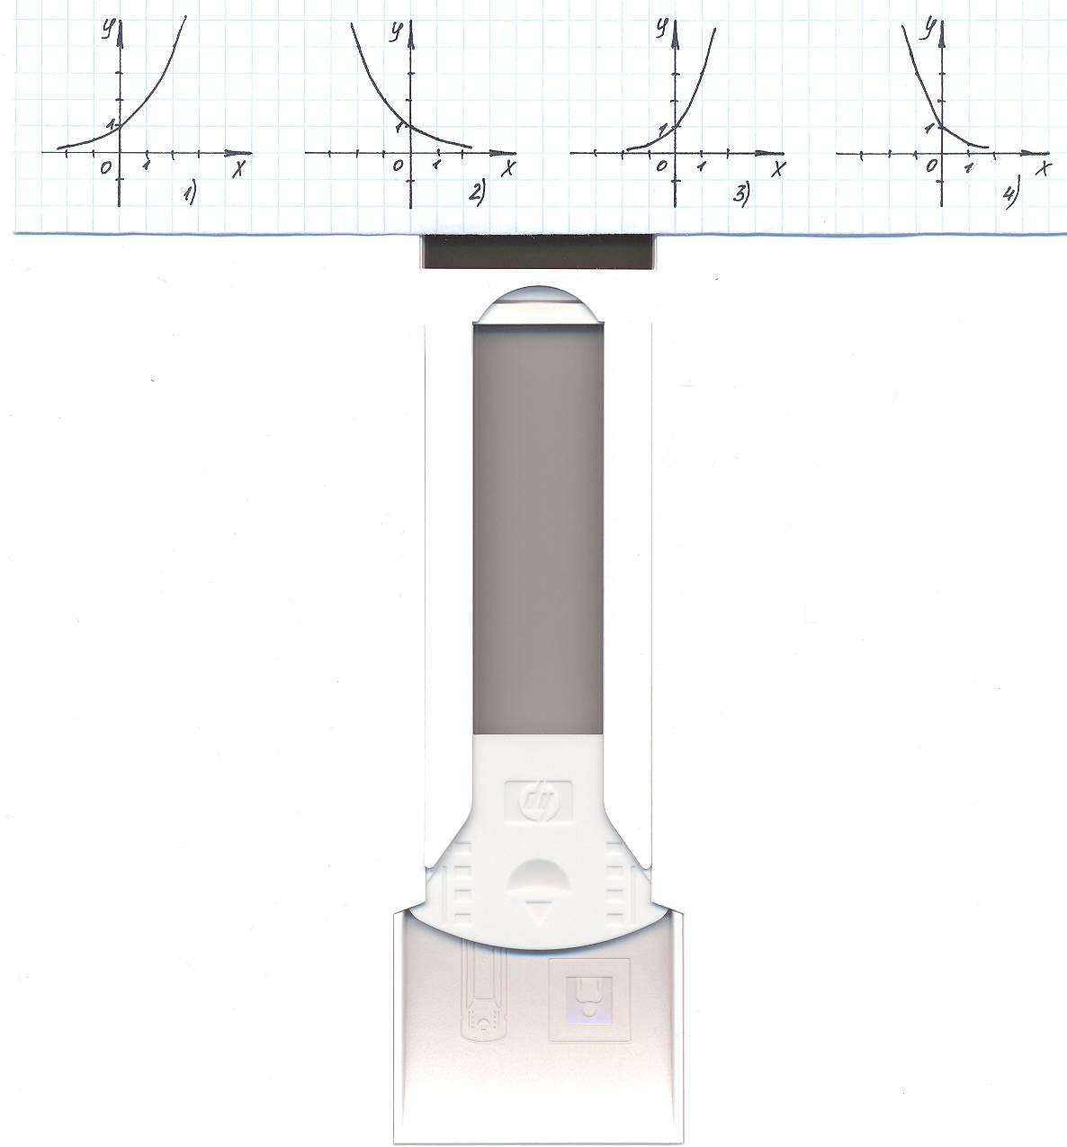

**2.** Укажите промежуток, которому принадлежит корень уравнения

1) (-4;-2] 2) (-2;0] 3) (2;4] 4) (0;2]

**3.** Решить неравенство  < .

1) (-∞;5) 2) (-∞;7) 3) (5;+ ∞) 4) (7;+ ∞)

**4.** Найти значение выражения: 2 log 2 7 + log 5 75 – log 53.

|  |  |  |  |
| --- | --- | --- | --- |
| 1) 9 | 2) 32 | 3) 51 | 4) 4 |

**5.** Укажите промежуток, которому принадлежит корень уравнения log 5 (9 -2x) = 2.

|  |  |  |  |
| --- | --- | --- | --- |
| 1) (-10;-7) | 2) (3;5) | 3) (-1;2) | 4) (-14;-11) |

**6.** Решить неравенство log 2 (2 – 0,7x) ≥ - 2.

|  |  |  |  |
| --- | --- | --- | --- |
| 1) | 2) ; | 3) (-∞;2,5]; | 4) [2,5; + ∞) |

**7.** Найти область определения функции у = .

1)  2) 3)  4) (-∞; 1,5]

**8.** Найти корень уравнения 7 ∙ 5х – 5 х+1 = 2 ∙ 5 -3.

|  |  |  |  |  |  |  |  |  |  |  |  |  |  |  |  |  |  |  |  |  |  |  |  |  |  |  |  |  |  |  |  |  |  |  |  |  |  |  |  |
| --- | --- | --- | --- | --- | --- | --- | --- | --- | --- | --- | --- | --- | --- | --- | --- | --- | --- | --- | --- | --- | --- | --- | --- | --- | --- | --- | --- | --- | --- | --- | --- | --- | --- | --- | --- | --- | --- | --- | --- |
|  |  |  |  |  |  |  |  |  |  |  |  |  |  |  |  |  |  |  |  |  |  |  |  |  |  |  |  |  |  |  |  |  |  |  |  |  |  |  |  |
|  |  |  |  |  |  |  |  |  |  |  |  |  |  |  |  |  |  |  |  |  |  |  |  |  |  |  |  |  |  |  |  |  |  |  |  |  |  |  |  |
|  |  |  |  |  |  |  |  |  |  |  |  |  |  |  |  |  |  |  |  |  |  |  |  |  |  |  |  |  |  |  |  |  |  |  |  |  |  |  |  |
|  |  |  |  |  |  |  |  |  |  |  |  |  |  |  |  |  |  |  |  |  |  |  |  |  |  |  |  |  |  |  |  |  |  |  |  |  |  |  |  |
|  |  |  |  |  |  |  |  |  |  |  |  |  |  |  |  |  |  |  |  |  |  |  |  |  |  |  |  |  |  |  |  |  |  |  |  |  |  |  |  |
|  |  |  |  |  |  |  |  |  |  |  |  |  |  |  |  |  |  |  |  |  |  |  |  |  |  |  |  |  |  |  |  |  |  |  |  |  |  |  |  |

**9.** Решить уравнение: 

|  |  |  |  |  |  |  |  |  |  |  |  |  |  |  |  |  |  |  |  |  |  |  |  |  |  |  |  |  |  |  |  |  |  |  |  |  |  |  |  |
| --- | --- | --- | --- | --- | --- | --- | --- | --- | --- | --- | --- | --- | --- | --- | --- | --- | --- | --- | --- | --- | --- | --- | --- | --- | --- | --- | --- | --- | --- | --- | --- | --- | --- | --- | --- | --- | --- | --- | --- |
|  |  |  |  |  |  |  |  |  |  |  |  |  |  |  |  |  |  |  |  |  |  |  |  |  |  |  |  |  |  |  |  |  |  |  |  |  |  |  |  |
|  |  |  |  |  |  |  |  |  |  |  |  |  |  |  |  |  |  |  |  |  |  |  |  |  |  |  |  |  |  |  |  |  |  |  |  |  |  |  |  |
|  |  |  |  |  |  |  |  |  |  |  |  |  |  |  |  |  |  |  |  |  |  |  |  |  |  |  |  |  |  |  |  |  |  |  |  |  |  |  |  |
|  |  |  |  |  |  |  |  |  |  |  |  |  |  |  |  |  |  |  |  |  |  |  |  |  |  |  |  |  |  |  |  |  |  |  |  |  |  |  |  |
|  |  |  |  |  |  |  |  |  |  |  |  |  |  |  |  |  |  |  |  |  |  |  |  |  |  |  |  |  |  |  |  |  |  |  |  |  |  |  |  |
|  |  |  |  |  |  |  |  |  |  |  |  |  |  |  |  |  |  |  |  |  |  |  |  |  |  |  |  |  |  |  |  |  |  |  |  |  |  |  |  |
|  |  |  |  |  |  |  |  |  |  |  |  |  |  |  |  |  |  |  |  |  |  |  |  |  |  |  |  |  |  |  |  |  |  |  |  |  |  |  |  |
|  |  |  |  |  |  |  |  |  |  |  |  |  |  |  |  |  |  |  |  |  |  |  |  |  |  |  |  |  |  |  |  |  |  |  |  |  |  |  |  |

**10.** Осевое сечение цилиндра - квадрат, диагональ которого 20 см. Найти площадь основания цилиндра.

|  |  |  |  |  |  |  |  |  |  |  |  |  |  |  |  |  |  |  |  |  |  |  |  |  |  |  |  |  |  |  |  |  |  |  |  |  |  |  |  |
| --- | --- | --- | --- | --- | --- | --- | --- | --- | --- | --- | --- | --- | --- | --- | --- | --- | --- | --- | --- | --- | --- | --- | --- | --- | --- | --- | --- | --- | --- | --- | --- | --- | --- | --- | --- | --- | --- | --- | --- |
|  |  |  |  |  |  |  |  |  |  |  |  |  |  |  |  |  |  |  |  |  |  |  |  |  |  |  |  |  |  |  |  |  |  |  |  |  |  |  |  |
|  |  |  |  |  |  |  |  |  |  |  |  |  |  |  |  |  |  |  |  |  |  |  |  |  |  |  |  |  |  |  |  |  |  |  |  |  |  |  |  |
|  |  |  |  |  |  |  |  |  |  |  |  |  |  |  |  |  |  |  |  |  |  |  |  |  |  |  |  |  |  |  |  |  |  |  |  |  |  |  |  |
|  |  |  |  |  |  |  |  |  |  |  |  |  |  |  |  |  |  |  |  |  |  |  |  |  |  |  |  |  |  |  |  |  |  |  |  |  |  |  |  |
|  |  |  |  |  |  |  |  |  |  |  |  |  |  |  |  |  |  |  |  |  |  |  |  |  |  |  |  |  |  |  |  |  |  |  |  |  |  |  |  |
|  |  |  |  |  |  |  |  |  |  |  |  |  |  |  |  |  |  |  |  |  |  |  |  |  |  |  |  |  |  |  |  |  |  |  |  |  |  |  |  |
|  |  |  |  |  |  |  |  |  |  |  |  |  |  |  |  |  |  |  |  |  |  |  |  |  |  |  |  |  |  |  |  |  |  |  |  |  |  |  |  |

**11.** Пусть (х0;у0) – решение системы уравнений

3 х ∙ 2 у = 576,

log (y – x) = 4. Найдите х0 + у0.

|  |  |  |  |  |  |  |  |  |  |  |  |  |  |  |  |  |  |  |  |  |  |  |  |  |  |  |  |  |  |  |  |  |  |  |  |  |  |  |  |
| --- | --- | --- | --- | --- | --- | --- | --- | --- | --- | --- | --- | --- | --- | --- | --- | --- | --- | --- | --- | --- | --- | --- | --- | --- | --- | --- | --- | --- | --- | --- | --- | --- | --- | --- | --- | --- | --- | --- | --- |
|  |  |  |  |  |  |  |  |  |  |  |  |  |  |  |  |  |  |  |  |  |  |  |  |  |  |  |  |  |  |  |  |  |  |  |  |  |  |  |  |
|  |  |  |  |  |  |  |  |  |  |  |  |  |  |  |  |  |  |  |  |  |  |  |  |  |  |  |  |  |  |  |  |  |  |  |  |  |  |  |  |
|  |  |  |  |  |  |  |  |  |  |  |  |  |  |  |  |  |  |  |  |  |  |  |  |  |  |  |  |  |  |  |  |  |  |  |  |  |  |  |  |
|  |  |  |  |  |  |  |  |  |  |  |  |  |  |  |  |  |  |  |  |  |  |  |  |  |  |  |  |  |  |  |  |  |  |  |  |  |  |  |  |
|  |  |  |  |  |  |  |  |  |  |  |  |  |  |  |  |  |  |  |  |  |  |  |  |  |  |  |  |  |  |  |  |  |  |  |  |  |  |  |  |
|  |  |  |  |  |  |  |  |  |  |  |  |  |  |  |  |  |  |  |  |  |  |  |  |  |  |  |  |  |  |  |  |  |  |  |  |  |  |  |  |
|  |  |  |  |  |  |  |  |  |  |  |  |  |  |  |  |  |  |  |  |  |  |  |  |  |  |  |  |  |  |  |  |  |  |  |  |  |  |  |  |
|  |  |  |  |  |  |  |  |  |  |  |  |  |  |  |  |  |  |  |  |  |  |  |  |  |  |  |  |  |  |  |  |  |  |  |  |  |  |  |  |

**12.** Решить уравнение 3 | sin x – 1 | = 9.

|  |  |  |  |  |  |  |  |  |  |  |  |  |  |  |  |  |  |  |  |  |  |  |  |  |  |  |  |  |  |  |  |  |  |  |  |  |  |  |
| --- | --- | --- | --- | --- | --- | --- | --- | --- | --- | --- | --- | --- | --- | --- | --- | --- | --- | --- | --- | --- | --- | --- | --- | --- | --- | --- | --- | --- | --- | --- | --- | --- | --- | --- | --- | --- | --- | --- |
|  |  |  |  |  |  |  |  |  |  |  |  |  |  |  |  |  |  |  |  |  |  |  |  |  |  |  |  |  |  |  |  |  |  |  |  |  |  |  |
|  |  |  |  |  |  |  |  |  |  |  |  |  |  |  |  |  |  |  |  |  |  |  |  |  |  |  |  |  |  |  |  |  |  |  |  |  |  |  |
|  |  |  |  |  |  |  |  |  |  |  |  |  |  |  |  |  |  |  |  |  |  |  |  |  |  |  |  |  |  |  |  |  |  |  |  |  |  |  |
|  |  |  |  |  |  |  |  |  |  |  |  |  |  |  |  |  |  |  |  |  |  |  |  |  |  |  |  |  |  |  |  |  |  |  |  |  |  |  |
|  |  |  |  |  |  |  |  |  |  |  |  |  |  |  |  |  |  |  |  |  |  |  |  |  |  |  |  |  |  |  |  |  |  |  |  |  |  |  |
|  |  |  |  |  |  |  |  |  |  |  |  |  |  |  |  |  |  |  |  |  |  |  |  |  |  |  |  |  |  |  |  |  |  |  |  |  |  |  |
|  |  |  |  |  |  |  |  |  |  |  |  |  |  |  |  |  |  |  |  |  |  |  |  |  |  |  |  |  |  |  |  |  |  |  |  |  |  |  |

**Промежуточная работа 11 класс**

*Вариант*

*К каждому заданию 1,2,3,5,6,7,8даны 4 варианта ответа, из которых только один правильный. Номера выбранных ответов на задания 1,2,3,5,6,7,8 обведите кружком.*

**1.** Укажите график функции, заданной формулой у = 3 х.

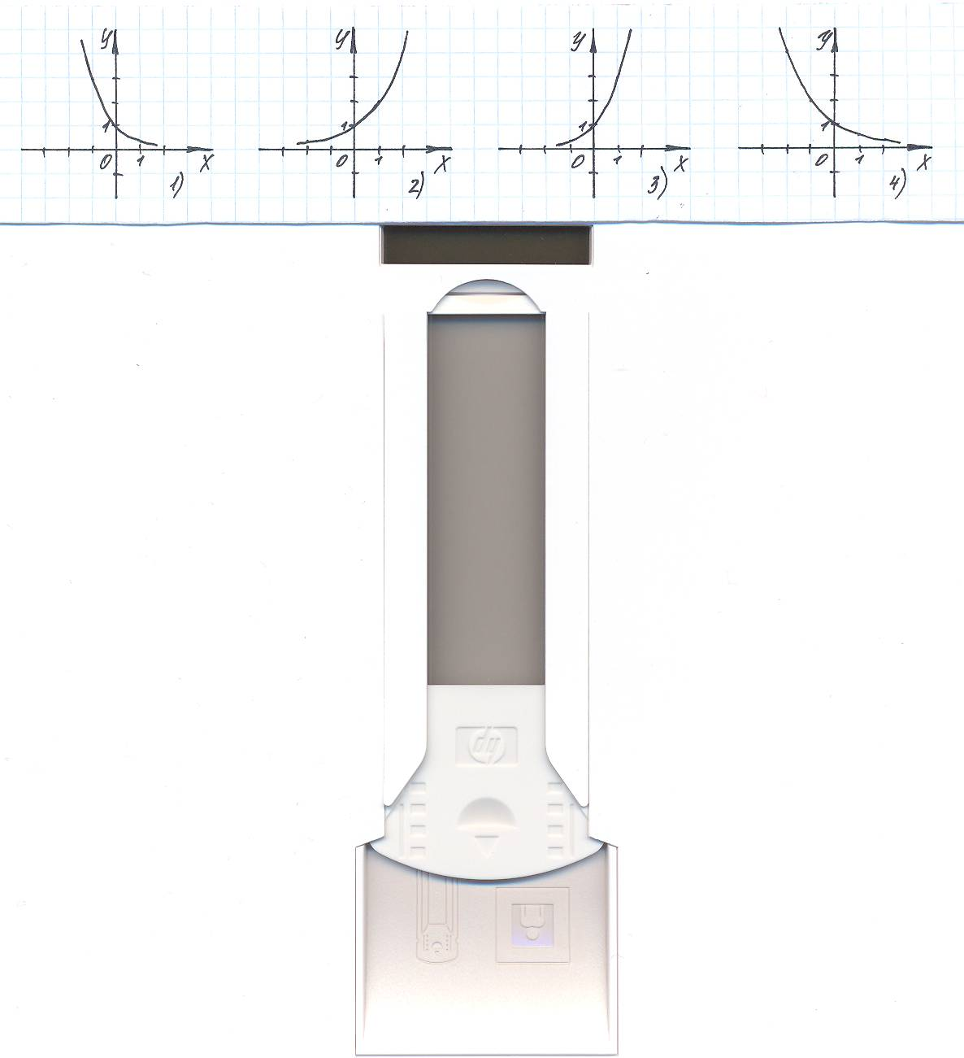

**2.** Укажите промежуток, которому принадлежит корень уравнения

|  |  |  |  |
| --- | --- | --- | --- |
| 1) (- 1; 0] | 2) (0; 1] | 3) (1; 2] | 4) (2; 3] |

**3.**  Решить неравенство 81 ∙ 3 х > .

|  |  |  |  |
| --- | --- | --- | --- |
| 1) (- 2; + $∞$) | 2) (- 6; + $∞$) | 3) ($-∞$; - 6) | 4) ($-∞$; - 6) |

**4.** Упростить выражение: 3  log 3 4.

|  |  |  |  |
| --- | --- | --- | --- |
| 1) 2 | 2) 8 | 3) 9 | 4) 16 |

**5.** Укажите промежуток, которому принадлежит корень уравнения lg (4x + 1) = 1.

|  |  |  |  |
| --- | --- | --- | --- |
| 1) (2; 3) | 2) (1; 2) | 3) (- 3; -2) | 4) (- 1; 1) |

**6.** Решить неравенство log  (6 – 0,3x) > -1

|  |  |  |  |
| --- | --- | --- | --- |
| 1) (-10; + $∞$) | 2) ($-∞$; -10) | 3) ( $-$ 10;20) | 4) ($-$ 0,1; 20) |

**7.** Найти область определения функции у = .

1) (;14]; 2) 3)  4) [14; + $∞$).

**8.** Решить уравнение 2 2х + 14 ∙ 2 х + 1 – 29 = 0

|  |  |  |  |  |  |  |  |  |  |  |  |  |  |  |  |  |  |  |  |  |  |  |  |  |  |  |  |  |  |  |  |  |  |  |  |  |  |  |  |
| --- | --- | --- | --- | --- | --- | --- | --- | --- | --- | --- | --- | --- | --- | --- | --- | --- | --- | --- | --- | --- | --- | --- | --- | --- | --- | --- | --- | --- | --- | --- | --- | --- | --- | --- | --- | --- | --- | --- | --- |
|  |  |  |  |  |  |  |  |  |  |  |  |  |  |  |  |  |  |  |  |  |  |  |  |  |  |  |  |  |  |  |  |  |  |  |  |  |  |  |  |
|  |  |  |  |  |  |  |  |  |  |  |  |  |  |  |  |  |  |  |  |  |  |  |  |  |  |  |  |  |  |  |  |  |  |  |  |  |  |  |  |
|  |  |  |  |  |  |  |  |  |  |  |  |  |  |  |  |  |  |  |  |  |  |  |  |  |  |  |  |  |  |  |  |  |  |  |  |  |  |  |  |
|  |  |  |  |  |  |  |  |  |  |  |  |  |  |  |  |  |  |  |  |  |  |  |  |  |  |  |  |  |  |  |  |  |  |  |  |  |  |  |  |

**9.** Найти корень уравнения 7 ∙ 5х – 5 х+1 = 2 ∙ 5 -3.

|  |  |  |  |  |  |  |  |  |  |  |  |  |  |  |  |  |  |  |  |  |  |  |  |  |  |  |  |  |  |  |  |  |  |  |  |  |  |  |  |
| --- | --- | --- | --- | --- | --- | --- | --- | --- | --- | --- | --- | --- | --- | --- | --- | --- | --- | --- | --- | --- | --- | --- | --- | --- | --- | --- | --- | --- | --- | --- | --- | --- | --- | --- | --- | --- | --- | --- | --- |
|  |  |  |  |  |  |  |  |  |  |  |  |  |  |  |  |  |  |  |  |  |  |  |  |  |  |  |  |  |  |  |  |  |  |  |  |  |  |  |  |
|  |  |  |  |  |  |  |  |  |  |  |  |  |  |  |  |  |  |  |  |  |  |  |  |  |  |  |  |  |  |  |  |  |  |  |  |  |  |  |  |
|  |  |  |  |  |  |  |  |  |  |  |  |  |  |  |  |  |  |  |  |  |  |  |  |  |  |  |  |  |  |  |  |  |  |  |  |  |  |  |  |
|  |  |  |  |  |  |  |  |  |  |  |  |  |  |  |  |  |  |  |  |  |  |  |  |  |  |  |  |  |  |  |  |  |  |  |  |  |  |  |  |
|  |  |  |  |  |  |  |  |  |  |  |  |  |  |  |  |  |  |  |  |  |  |  |  |  |  |  |  |  |  |  |  |  |  |  |  |  |  |  |  |
|  |  |  |  |  |  |  |  |  |  |  |  |  |  |  |  |  |  |  |  |  |  |  |  |  |  |  |  |  |  |  |  |  |  |  |  |  |  |  |  |

**10.** Пусть (х0;у0) – решение системы уравнений

10 1 + lg (x + y) = 50,

lg (x + y) + lg (x – y) = 2 – lg 5. Найдите х0 + у0.

|  |  |  |  |  |  |  |  |  |  |  |  |  |  |  |  |  |  |  |  |  |  |  |  |  |  |  |  |  |  |  |  |  |  |  |  |  |  |  |  |
| --- | --- | --- | --- | --- | --- | --- | --- | --- | --- | --- | --- | --- | --- | --- | --- | --- | --- | --- | --- | --- | --- | --- | --- | --- | --- | --- | --- | --- | --- | --- | --- | --- | --- | --- | --- | --- | --- | --- | --- |
|  |  |  |  |  |  |  |  |  |  |  |  |  |  |  |  |  |  |  |  |  |  |  |  |  |  |  |  |  |  |  |  |  |  |  |  |  |  |  |  |
|  |  |  |  |  |  |  |  |  |  |  |  |  |  |  |  |  |  |  |  |  |  |  |  |  |  |  |  |  |  |  |  |  |  |  |  |  |  |  |  |
|  |  |  |  |  |  |  |  |  |  |  |  |  |  |  |  |  |  |  |  |  |  |  |  |  |  |  |  |  |  |  |  |  |  |  |  |  |  |  |  |
|  |  |  |  |  |  |  |  |  |  |  |  |  |  |  |  |  |  |  |  |  |  |  |  |  |  |  |  |  |  |  |  |  |  |  |  |  |  |  |  |
|  |  |  |  |  |  |  |  |  |  |  |  |  |  |  |  |  |  |  |  |  |  |  |  |  |  |  |  |  |  |  |  |  |  |  |  |  |  |  |  |
|  |  |  |  |  |  |  |  |  |  |  |  |  |  |  |  |  |  |  |  |  |  |  |  |  |  |  |  |  |  |  |  |  |  |  |  |  |  |  |  |
|  |  |  |  |  |  |  |  |  |  |  |  |  |  |  |  |  |  |  |  |  |  |  |  |  |  |  |  |  |  |  |  |  |  |  |  |  |  |  |  |

**11.** Решить уравнение 2 | cos x – 2 | = 8

|  |  |  |  |  |  |  |  |  |  |  |  |  |  |  |  |  |  |  |  |  |  |  |  |  |  |  |  |  |  |  |  |  |  |  |  |  |  |  |
| --- | --- | --- | --- | --- | --- | --- | --- | --- | --- | --- | --- | --- | --- | --- | --- | --- | --- | --- | --- | --- | --- | --- | --- | --- | --- | --- | --- | --- | --- | --- | --- | --- | --- | --- | --- | --- | --- | --- |
|  |  |  |  |  |  |  |  |  |  |  |  |  |  |  |  |  |  |  |  |  |  |  |  |  |  |  |  |  |  |  |  |  |  |  |  |  |  |  |
|  |  |  |  |  |  |  |  |  |  |  |  |  |  |  |  |  |  |  |  |  |  |  |  |  |  |  |  |  |  |  |  |  |  |  |  |  |  |  |
|  |  |  |  |  |  |  |  |  |  |  |  |  |  |  |  |  |  |  |  |  |  |  |  |  |  |  |  |  |  |  |  |  |  |  |  |  |  |  |
|  |  |  |  |  |  |  |  |  |  |  |  |  |  |  |  |  |  |  |  |  |  |  |  |  |  |  |  |  |  |  |  |  |  |  |  |  |  |  |
|  |  |  |  |  |  |  |  |  |  |  |  |  |  |  |  |  |  |  |  |  |  |  |  |  |  |  |  |  |  |  |  |  |  |  |  |  |  |  |
|  |  |  |  |  |  |  |  |  |  |  |  |  |  |  |  |  |  |  |  |  |  |  |  |  |  |  |  |  |  |  |  |  |  |  |  |  |  |  |
|  |  |  |  |  |  |  |  |  |  |  |  |  |  |  |  |  |  |  |  |  |  |  |  |  |  |  |  |  |  |  |  |  |  |  |  |  |  |  |
|  |  |  |  |  |  |  |  |  |  |  |  |  |  |  |  |  |  |  |  |  |  |  |  |  |  |  |  |  |  |  |  |  |  |  |  |  |  |  |
|  |  |  |  |  |  |  |  |  |  |  |  |  |  |  |  |  |  |  |  |  |  |  |  |  |  |  |  |  |  |  |  |  |  |  |  |  |  |  |

**Критерии оценивания работы в 11 классе**

Максимальный балл за каждое верно решенное задание

№ 1 – 9 зад– 1 балл,

№ 10, 11 – 2 балла.

Максимальный балл по всему тесту – 13 баллов

**Перевод тестовых баллов в школьные отметки**

|  |  |
| --- | --- |
| **Тестовый балл** | **Отметка** |
| 0 – 4 | «2» |
| 5 – 7 | «3» |
| 8 – 10 | «4» |
| 11-13 | «5» |

**Критерии оценки выполнения задания**

|  |  |  |
| --- | --- | --- |
| **№ задания** | **Количество баллов** | **Характеристика оценивания задания** |
| **10** | 2 | Ход решения верный, получен верный результат. |
| 1 | Ход решения верный, допущена вычислительная ошибка |
| 0 | Все случаи решения, которые не соответствуют вышеуказанным критериям оценки в 1, 2 балла |
| **11** | 2 | Ход решения верный, получен правильный ответ |
| 1 | Рассмотрен 1случай для модуля |
| 0 | Все случаи решения, которые не соответствуют вышеуказанным критериям оценки в 1, 2 балла. |

**Итоговая контрольная работа**

**по математике (алгебре и началам математического анализа)11 класс**

**Вариант**

**Часть 1**

**А1.** Укажите наименьшее значение функции у = 2 – 5sin x.

**А2.** Найдите производную функции у = 2х + cos х.

**А3.**

|  |  |
| --- | --- |
|  | На рисунке изображены график функции у = f(x) и касательная к нему в точке с абсциссой *х0*.  Найдите значение производной функции f(x) в точке *х0.* |

**А4.**

|  |  |
| --- | --- |
|  | На рисунке изображен график производной функции у = f(x), определённой на (-10; 4). Найдите промежутки убывания функции f(x). В ответе укажите длину наибольшего из них. |

**А5.**

|  |  |
| --- | --- |
|  | На рисунке изображен график производной функции у = f(x), определённой на (-5; 5).  В какой точке отрезка [-4; -1] f(x) принимает наибольшее значение. |

**Часть 2**

**В1.** Найдите первообразную F(x) функции *f(x) = $\frac{1}{\sqrt{x+1}}$* *+ 2х,* если график первообразной проходит через точку М(3; 13).

**В2.** В случайном эксперименте бросают две игральные кости. Найдите вероятность того, что в сумме выпадет 7 очков. Результат округлите до сотых.

**В3.** Тело движется прямолинейно по закону *х(t) = 2t4 - 3t3 – 5t2 (x* в метрах, t в секундах). Найдите его скорость и ускорение в момент времени t = 10c.

**В4.** Касательная к графику функции f(x) = 2x3 – 3x2 – 4 параллельна прямой у = 12х + 1. Найдите абсциссу точки касания.

**В5.** Дана функция f(x) = 8x2 – x4 . Найдите:

А) промежутки возрастания и убывания функции;

Б) точки максимума и минимума функции;

В) наибольшее и наименьшее значения функции

на отрезке [-1; 3] .

**В6.** Найдите площадь фигуры, ограниченной графиком функции

f(x) = -x2 + 6x - 5, прямыми х = 2, х = 3 и осью абсцисс, изобразив рисунок.

**В7.** Найдите все решения уравнения cos 2x + sin x = cos2 x, принадлежащие отрезку [0; 2π].

**Система оценивания заданий и работы в целом**

За верное выполнение каждого задания 1 части обучающийся получает 3балла, за верное выполнение каждого задания 2 части-5 баллов.

За неверный ответ или его отсутствие выставляется 0 баллов. Максимальное количество баллов, которое может набрать обучающийся, правильно выполнивший задания 1 части работы-15 балла, задания 2 части работы-35 баллов .Максимальное количество баллов за выполнение всей работы-50 баллов.

**Шкала перевода набранных баллов в отметку усвоения:**

|  |  |  |  |  |
| --- | --- | --- | --- | --- |
| Баллы | отметка | Повышенный | Базовый | Пониженный |
| 50-45 | 5 | + |  |  |
| 44-35 | 4 |  |  |
| 34-25 | 3 |  | + |  |
| 24 и менее | 2 |  |  | + |

**Критерии оценивания заданий части 1**

|  |  |
| --- | --- |
| **Баллы** | **Критерии оценки выполнения задания** |
| 3 | Получен верный ответ |
| 2 | Правильно выбраны действия, но есть ошибки в вычислениях. |
|  |  |
| 1 | Правильно выбраны действия, но решение не закончено. |

**Критерии оценивания заданий части 2 (С1-С2)**

|  |  |
| --- | --- |
| **Баллы** | **Критерии оценки выполнения задания** |
| 5 | Обоснованно получен верный ответ. |
| 4 | Верный ход решения, но есть вычислительная ошибка. |
| 3 | Правильно выбраны действия, но решение не закончено. |

|  |  |
| --- | --- |
| 2 | Ответ верный, но выполнение действий не прописано. |
| 1 | Действия выбраны неверно, но записан верный ответ. |